/**

Name of program : Example 1

Author : Mangesh Dikshit

Roll No : 34

Batch : T4

Date of Performance : 28/09/2023

**/

class Example

{

public static void main(String args[])

{

System.out.println("This is simple java program");

}

}

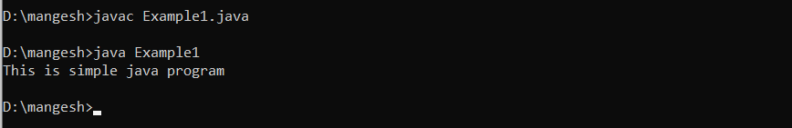

/**

Name of program : Example 2

Author : Mangesh Dikshit

Roll No : 34

Batch : T4

Date of Performance : 28/09/2023

**/

class Example2

{

public static void main(String args[])

{

int num;

num =100;

System.out.println("This is num: " + num);

num =num*2;

System.out.print("The value of num 2 is ");

System.out.println(num);

}

}

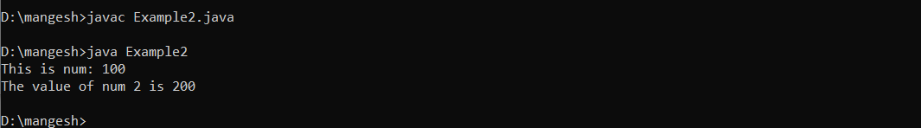

/**

Name of program : Light

Author : Mangesh Dikshit

Roll No : 34

Batch : T4

Date of Performance : 28/09/2023

**/

class Light

{

public static void main(String v[])

{

int lightspeed;

long days;

long seconds;

long distance;

lightspeed = 186000;

days = 1000;

seconds = days * 24 * 60 * 60;

distance = lightspeed * seconds;

System.out.print("In " + days);

System.out.print(" days light will travel about ");

System.out.println(distance + " miles.");

}

}

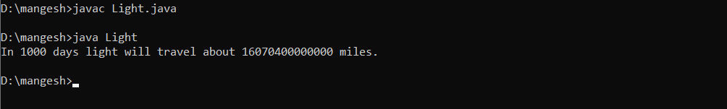

/**

Name of program : Area

Author : Mangesh Dikshit

Roll No : 34

Batch : T4

Date of Performance : 28/09/2023

**/

class Area

{

public static void main(String args[])

{

double pi, r, a;

r = 10.8;

pi = 3.1416;

a = pi * r * r;

System.out.println("Area of circle is " + a);

}

}

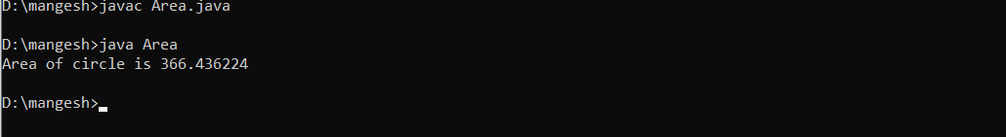

/**

Name of program : CharDemo

Author : Mangesh Dikshit

Roll No : 34

Batch : T4

Date of Performance : 28/09/2023

**/

class CharDemo

{

public static void main(String Args[])

{

char ch1,ch2;

ch1=88;

ch2='Y';

System.out.println("ch1 and ch2: ");

System.out.println(ch1 +" "+ch2);

}

}

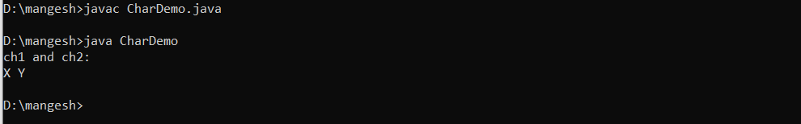

/**

Name of program : CharDemo2

Author : Mangesh Dikshit

Roll No : 34

Batch : T4

Date of Performance : 28/09/2023

**/

class CharDemo2{

public static void main(String args[]){

char ch1;

ch1='x';

System.out.println("ch1 contains"+ch1);

ch1++;

System.out.println("ch1 is now"+ch1);

}

}

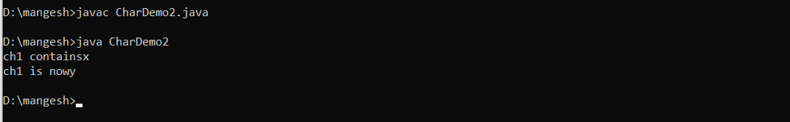

/**

Name of program : BoolTest

Author : Mangesh Dikshit

Roll No : 34

Batch : T4

Date of Performance : 28/09/2023

**/

class BoolTest

{

public static void main(String args[])

{

boolean b;

b = false;

System.out.println("b is " + b);

b = true;

System.out.println("b is " + b);

if(b)

System.out.println("This is executed.");

b = false;

if(b)

System.out.println("This is not executed.");

System.out.println("10 < 11 is " + (10 <11));

}

}

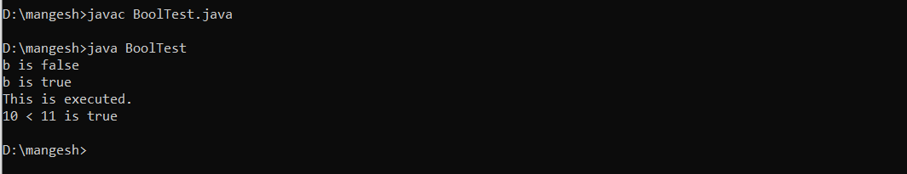

/**

Name of program : Scope

Author : Mangesh Dikshit

Roll No : 34

Batch : T4

Date of Performance : 28/09/2023

**/

class Scope

{

public static void main(String args[])

{

int x;

x = 10;

if(x == 10)

{

int y = 20;

System.out.println("x and y: " + x + " " + y);

x = y * 2;

}

System.out.println("x is " + x);

}

}

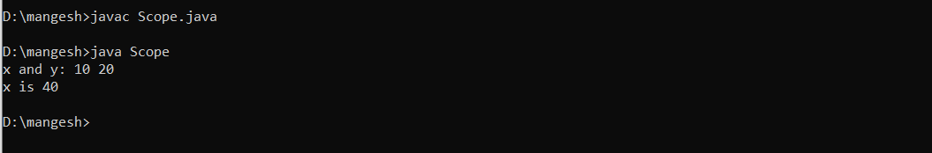

/**Name of program : LifeTime

Author : Mangesh Dikshit

Roll No : 34

Batch : T4

Date of Performance : 28/09/2023

**/

class LifeTime

{

public static void main(String args[])

{

int x;

int y=200;

for(x = 0; x < 3; x++)

{

int Y = -1;

System.out.println("y is: " + Y);

Y = 100;

System.out.println("y is now: " + Y);

}

System.out.println("y is now: " + y);

}

}

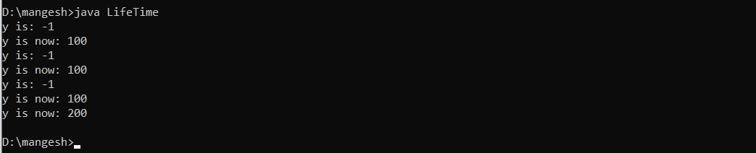

/**

Name of program : Conversion2

Author : Mangesh Dikshit

Roll No : 34

Batch : T4

Date of Performance : 28/09/2023

**/

class Conversion

{

public static void main(String args[])

{

byte b;

int i=157;

double d=129.142;

short s;

System.out.println("conversion of int to short");

s=(short)i;

System.out.println("i and s :"+i+" "+s);

System.out.println("\n conversion of double into short");

s=(short)d;

System.out.println("d and s :"+d+" "+s);

System.out.println("\n conversion of short into byte");

b=(byte)s;

System.out.println("s and b: "+s+" "+b);

}

}

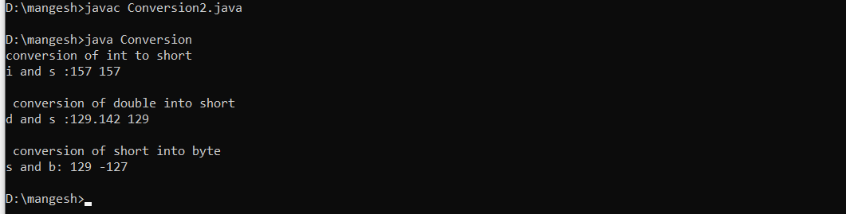

/**

Name of program : Conversion

Author : Mangesh Dikshit

Roll No : 34

Batch : T4

Date of Performance : 28/09/2023

**/

class Conversion1

{

public static void main(String args[])

{

byte b;

int i=157;

double d=129.142;

System.out.println("in conversion of int to byte");

b=(byte)i;

System.out.println("i and b:"+i+" "+b);

System.out.println("\n conversion of double into int");

i=(int)d;

System.out.println("d and i:"+d+" "+i);

System.out.println("\n conversion of double into byte");

b=(byte)d;

System.out.println("d and b"+d+" "+b);

}

}

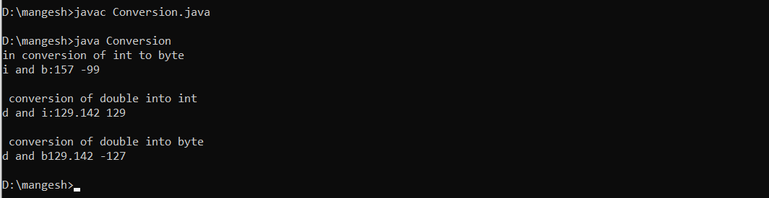

/**

Name of program : Prompt

Author : Mangesh Dikshit

Roll No : 34

Batch : T4

Date of Performance : 28/09/2023

**/

Class Prompt

{

public static void main(String args[])

{

byte b=42;

char c =’a’;

short s=.1024;

int i=50000;

float f=5.67f;

double d=.1234;

double result=(f*b)+(i/c)-(d*s);

System.out.println((f* b) +”+”+ (i/c)+”-“+(d*s));

System.out.println("result: “+result);

}

}

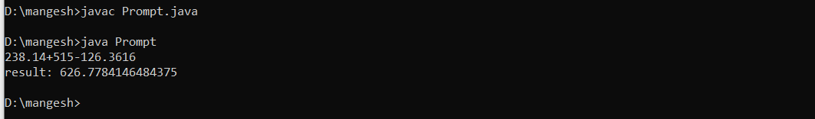

/**

Name of program : BoolLogic

Author : Mangesh Dikshit

Roll No : 34

Batch : T4

Date of Performance : 28/09/2023

**/

class BoolLogic

{

public static void main(String Args[])

{

boolean a=true;

boolean b=false;

boolean c=a|b;

boolean d=a&b;

boolean e=a^b;

boolean f=(!a&b)|(a&!b);

boolean g=!a;

System.out.println("a: "+a);

System.out.println("b: "+b);

System.out.println("a|b: "+c);

System.out.println("a&d: "+d);

System.out.println("a^b: "+e);

System.out.println("(!a&b)|(a&!b): "+f);

System.out.println("!a: "+g);

}

}

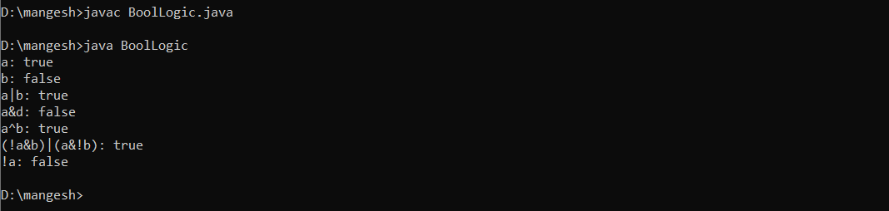

/**

Name of program : BitLogic

Author : Mangesh Dikshit

Roll No : 34

Batch : T4

Date of Performance : 28/09/2023

**/

class BitLogic

{

public static void main(String args[])

{

int a = 3; // 0 + 2 + 1 or 0011 in binary

int b = 6; // 4 + 2 + 0 or 0110 in binary

int c = a | b;

int d = a & b;

int e = a ^ b;

int f = (~a & b) | (a & ~b);

System.out.println(" a = " + a);

System.out.println(" b = " + b);

System.out.println(" a|b = " + c);

System.out.println(" a&b = " + d);

System.out.println(" a^b = " + e);

System.out.println("~a&b|a&~b = " + f);

}

}

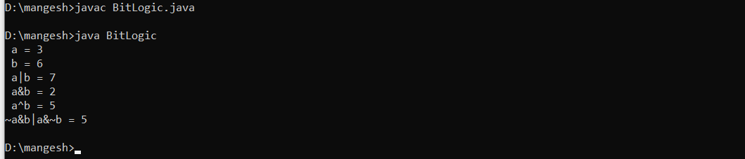

/**

Name of program : Even

Author : Mangesh Dikshit

Roll No : 34

Batch : T4

Date of Performance : 28/09/2023

**/

class Even

{

public static void main(String args[])

{

int a=4;

if(a%2==0)

{

System.out.println("Number is Even");

}

}

}

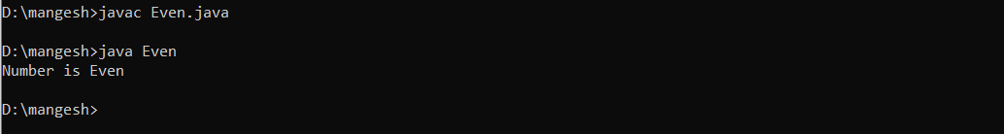

/**

Name of program : EvenOdd

Author : Mangesh Dikshit

Roll No : 34

Batch : T4

Date of Performance : 28/09/2023

**/

class EvenOdd

{

public static void main(String args[])

{

int a=5;

if(a%2==0)

{

System.out.println("Number is even");

}

Else

{

System.out.println("Number is odd");

}

}

}

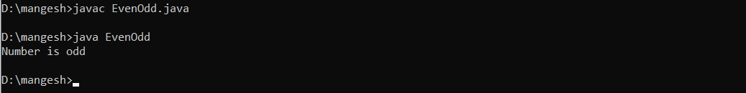

/**

Name of program : IfElse

Author : Mangesh Dikshit

Roll No : 34

Batch : T4

Date of Performance : 28/09/2023

**/

class IfElse

{

public static void main(String args[])

{

int month = 7; // July

String season;

if(month == 12 || month == 1 || month == 2)

season = "Winter";

else if(month == 3 || month == 4 || month == 5)

season = "Spring";

else if(month == 6 || month == 7 || month == 8)

season = "Summer";

else if(month == 9 || month == 10 || month == 11)

season = "Autumn";

else

season = "Bogus Month";

System.out.println("July is in the " + season + ".");

}

}

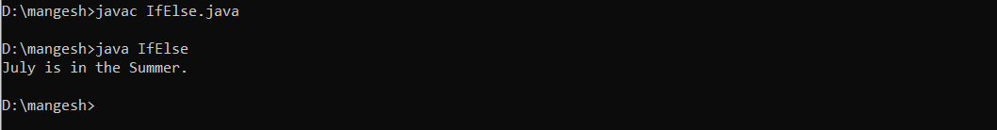

/**

Name of program : SampleSwitch

Author : Mangesh Dikshit

Roll No : 34

Batch : T4

Date of Performance : 28/09/2023

**/

class SampleSwitch{

public static void main(String args[]){

for(int i=0;i<6;i++){

switch(i){

case 0:

System.out.println("i is zero");

break;

case 1:

System.out.println("i is one");

break;

case 2:

System.out.println("i is two");

break;

case 3:

System.out.println("i is three");

break;

default:

System.out.println("i is greater than three");

}}}}

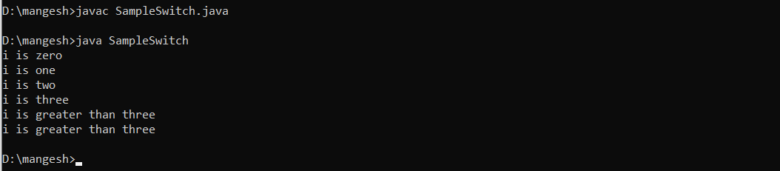

/**

Name of program : MissingBreak

Author : Mangesh Dikshit

Roll No : 34 Batch : T4 Date of Performance : 28/09/2023

**/

class MissingBreak{

public static void main(String args[]){

for(int i=0;i<12;i++)

switch(i){

case 0:

case 1:

case 2:

case 3:

case 4:

System.out.println("i is less than 5");

break;

case 5:

case 6:

case 7:

case 8:

case 9:

System.out.println("i is less than 10");

break;

default:

System.out.println("i is 10 or more");

}}}

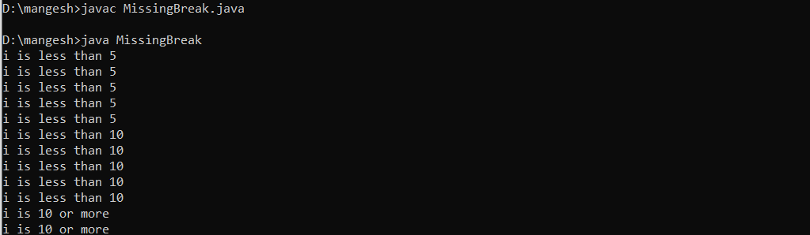

/**

Name of program : While

Author : Mangesh Dikshit

Roll No : 34

Batch : T4

Date of Performance : 28/09/2023

**/

class While

{

public static void main(String args[])

{

int n = 10;

while(n > 0)

{

System.out.println("tick " + n);

n--;

}

}

}

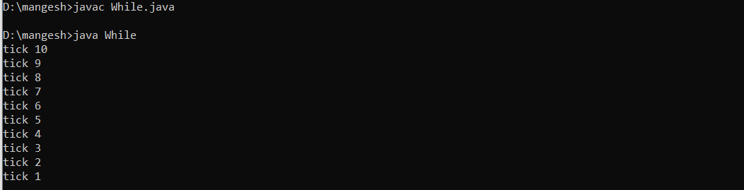

/**

Name of program : NoBody

Author : Mangesh Dikshit

Roll No : 34

Batch : T4

Date of Performance : 28/09/2023

**/

class NoBody{

public static void main(String args[]){

int i,j;

i=100;

j=200;

while(++i < --j);

{

System.out.println("Skip while loop");

}

System.out.println("Midpoint is " +i);

}

}

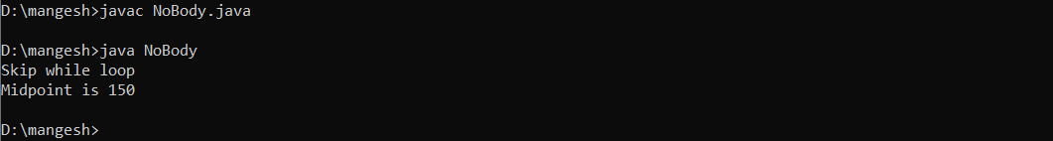

/**

Name of program : Array

Author : Mangesh Dikshit

Roll No : 34

Batch : T4

Date of Performance : 28/09/2023

**/

class Array {

public static void main(String args[]) {

int month_days[];

month_days = new int[12];

month_days[0] = 31;

month_days[1] = 28;

month_days[2] = 31;

month_days[3] = 30;

month_days[4] = 31;

month_days[5] = 30;

month_days[6] = 31;

month_days[7] = 31;

month_days[8] = 30;

month_days[9] = 31;

month_days[10] = 30;

month_days[11] = 31;

System.out.println("April has " + month_days[3] + " days.");

}}

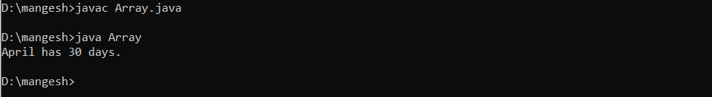

/**Name of program : MulTable

Author : Mangesh Dikshit

Roll No : 34

Batch : T4

Date of Performance : 28/09/2023

**/

class MulTable{

final static int ROWS=20;

final static int COLUMNS=20;

public static void main(String args[]){

int product[][]=new int[ROWS][COLUMNS];

int row,column;

System.out.println("MULTIPLICATION TABLE: ");

System.out.println(" ");

int i,j;

for(i=10; i<ROWS; i++){

for(j=10; j<COLUMNS; j++){

product[i][j]=i*j;

System.out.print(" "+product[i][j]);

}

System.out.println(" ");

}}}

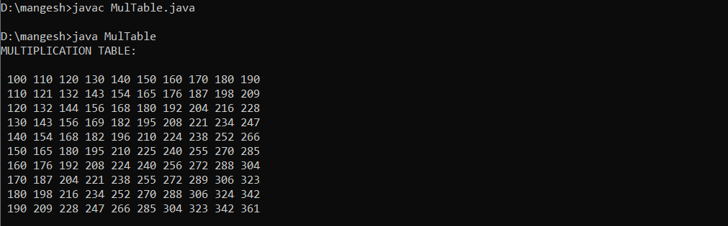

/**Name of program : LanguageVector

Author : Mangesh Dikshit

Roll No : 34

Batch : T4

Date of Performance : 28/09/2023

**/

import java.util.*;

class LanguageVector{

public static void main(String args[]){

Vector list=new Vector();

int length=args.length;

for(int i=0;i<length;i++){

list.addElement(args[i]);

}

list.insertElementAt("COBOL",2);

int size=list.size();

String listArray[]=new String[size];

list.copyInto(listArray);

System.out.println("List of Languages");

for(int i=0;i<size;i++){

System.out.println(listArray[i]);

}}}

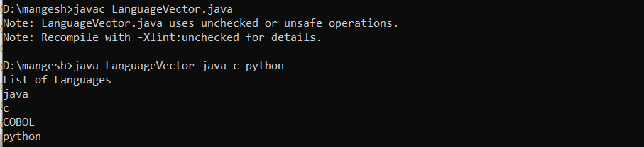

/**

Name of program : StringManipulation

Author : Mangesh Dikshit

Roll No : 34

Batch : T4

Date of Performance : 28/09/2023

**/

class StringManipulation

{

public static void main(String args[])

{

StringBuffer str=new StringBuffer("Object Language");

System.out.println("Original String: "+str);

System.out.println("length of string: "+str.length());

for(int i=0; i<str.length(); i++)

{

int p=i+1;

System.out.println("Character at position: "+p+" is "+str.charAt(i));

}

String aString=new String(str.toString());

System.out.println("length of string: "+ aString.length());

int pos=aString.indexOf(" Language");

str.insert(pos," Oriented");

System.out.println("Modified string: "+str);

str.setCharAt(6,'A');

System.out.println("String now: "+str);

str.append("Improves security.");

System.out.println("Append String: "+str);

}

}

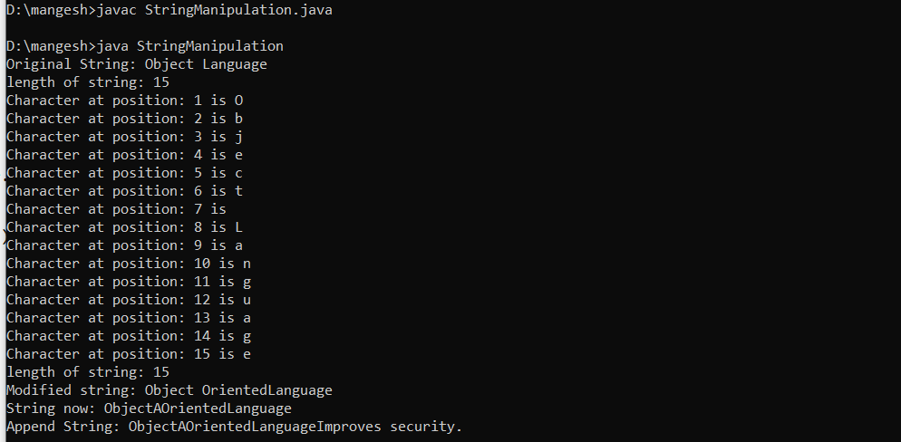

/**

Name of program : Enumdemo

Author : Mangesh Dikshit

Roll No : 34

Batch : T4

Date of Performance : 28/09/2023

**/

class Enumdemo

{

enum Days{Sun,Mon,Tue,Wen,Thu,Fri,Sat}

public static void main(String args[])

{

for(Days d: Days.values())

{

System.out.println("Day is ="+d);

}}}

